**Dharmsinh Desai University, Nadiad**

**Department of Information Technology**

**Advanced Java Technology, IT619**

**B.Tech. IT, Sem: VI**

**Experiment – 10**

**Submitted By**

**Roll No.: IT076**

**Name: Dishant Modh**

**Aim:**  Create a RMI based client-server application. The server allows access of bank

account object to client through RMI mechanism. The account object allows following

operations: deposit, withdraw, and balance. The server stores account data in database.

Design appropriate interface and test implementation on network.

**File Structure:**

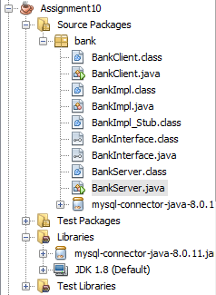

**Code:**

* **BankInterface.java**

package bank;

/**

*

* @author DC

*/

import java.rmi.*;

public interface BankInterface extends Remote{

public String Deposit(int accno,double amt)throws RemoteException;

public String Withdraw(int accno,double amt) throws RemoteException;

public String showBalance(int accno)throws RemoteException;

}

* **BankImpl.java**

package bank;

import java.rmi.*;

import java.rmi.server.*;

import java.sql.*;

/**

*

* @author DC

*/

public class BankImpl extends UnicastRemoteObject implements BankInterface {

String url = "jdbc:mysql://localhost:3306/bank";

String driver = "com.mysql.cj.jdbc.Driver";

Connection cn = null;

PreparedStatement pstat = null;

ResultSet rs = null;

public BankImpl() throws RemoteException {

try {

Class.forName(driver);

cn = DriverManager.getConnection(url, "root", "");

} catch (ClassNotFoundException e) {

System.out.println("Exception: " + e.toString());

} catch (SQLException ex) {

System.out.println("Exception: " + ex);

}

}

@Override

public String Deposit(int accno, double amt) throws RemoteException {

String getbal = new String("Select Balance from bank where AccountNo=?");

double bal = 0;

try {

pstat = cn.prepareStatement(getbal);

pstat.setInt(1, accno);

rs = pstat.executeQuery();

while (rs.next()) {

bal = rs.getDouble(1);

}

} catch (Exception e) {

System.out.println("Exception: " + e);

}

String query = "UPDATE bank set Balance=? where AccountNo=?";

try {

pstat = cn.prepareStatement(query);

pstat.setDouble(1, (bal + amt));

pstat.setInt(2, accno);

pstat.executeUpdate();

System.out.println("Deposit:"+amt+"\tAccount No: " +accno +"\tBalance: "+bal);

} catch (Exception e) {

System.out.println("Exception: " + e);

}

return "Deposit successful!";

}

@Override

public String Withdraw(int accno, double amt) throws RemoteException {

String getbal = "Select Balance from bank where AccountNo=?";

double bal = 0;

try {

pstat = cn.prepareStatement(getbal);

pstat.setInt(1, accno);

rs = pstat.executeQuery();

while (rs.next()) {

bal = rs.getDouble(1);

}

} catch (Exception e) {

System.out.println("Exception: " + e);

}

if (bal > amt) {

String query = "UPDATE bank set Balance=? where AccountNo=?";

try {

pstat = cn.prepareStatement(query);

pstat.setDouble(1, (bal - amt));

pstat.setInt(2, accno);

pstat.executeUpdate();

System.out.println("Withdraw:"+amt+"\tAccount No: " +accno +"\tBalance: "+bal);

} catch (Exception e) {

System.out.println("Exception: " + e);

}

return "Withdraw successful!";

} else {

return "Insufficient balance";

}

}

@Override

public String showBalance(int accno) throws RemoteException {

String getbal = "Select Balance from bank where AccountNo=?";

double bal = 0;

try {

pstat = cn.prepareStatement(getbal);

pstat.setInt(1, accno);

rs = pstat.executeQuery();

while (rs.next()) {

bal = rs.getDouble(1);

}

System.out.println("Account No: " +accno +"\tBalance: "+bal);

} catch (Exception e) {

System.out.println("Exception: " + e);

}

return "Your Balance is " + bal;

}

}

* **BankServer.java**

package bank;

import java.rmi.*;

import java.rmi.registry.LocateRegistry;

import java.rmi.registry.Registry;

/**

*

* @author DC

*/

public class BankServer {

/**

*

* @param args

*/

public static void main(String[] args) {

try {

BankInterface b = new BankImpl();

// Naming.rebind("rmi://127.0.0.1:1088/Test", b);

Registry reg = LocateRegistry.createRegistry(9999);

reg.rebind("server", b);

System.out.println("Server is ready to connect...");

} catch (Exception e) {

System.out.println("Exception: " + e);

}

}

}

* **BankClient.java**

package bank;

import java.rmi.NotBoundException;

import java.rmi.*;

/**

*

* @author DC

*/

public class BankClient {

public static void main(String[] args)

{

try{

//System.setSecurityManager(new RMISecurityManager());

BankInterface tsi = (BankInterface) Naming.lookup("rmi://localhost:9999/server");

System.out.println("Result = "+tsi.showBalance(1001));

System.out.println("Result = "+tsi.showBalance(1002));

System.out.println("Result = "+tsi.Deposit(1001,500));

System.out.println("Result = "+tsi.Withdraw(1002,800));

System.out.println("Result = "+tsi.showBalance(1001));

System.out.println("Result = "+tsi.showBalance(1002));

}

catch(Exception e)

{

System.out.println("Exception: "+e);

}

}

}

**Input/Output:**

**Data in Database before execution of program:**

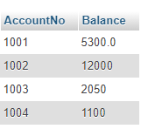

**Output at Clientside Console:**

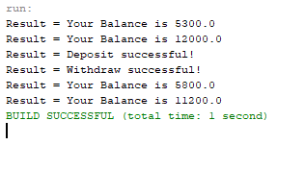

**Output at Serverside Console:**

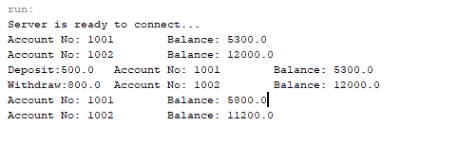

**Data in Database after Deposite and Withdraw money:**

